Income Tax

Assessment year = An year before the current financial year. For Example, If current financial year is 2023-24 then assessment year would be 2024-25, if current financial year is 2022-23 then assessment year will be 2023-24.

Income tax is imposed and recovered by Central Government

We always need to find the taxable income. Upon find it we need to apply the respective rates to calculate income tax. Rates are decided based on assessment year.

For Example: For income occurred in financial year 2022-2023, tax slabs announced in march 2023 will be applicable.

Surcharges are also involved if income is high. Also Health and Education cess are also applicable.

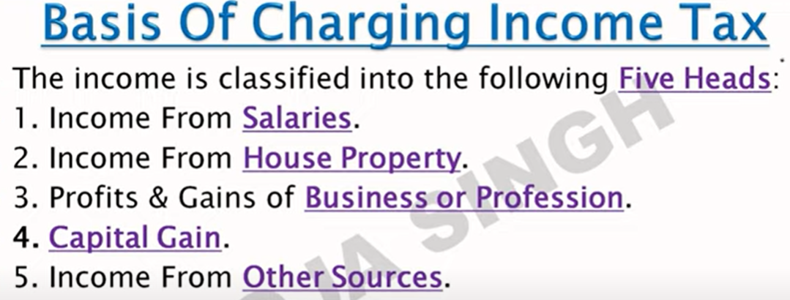

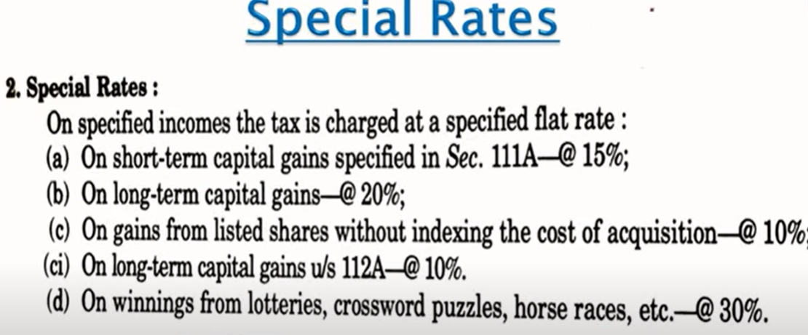

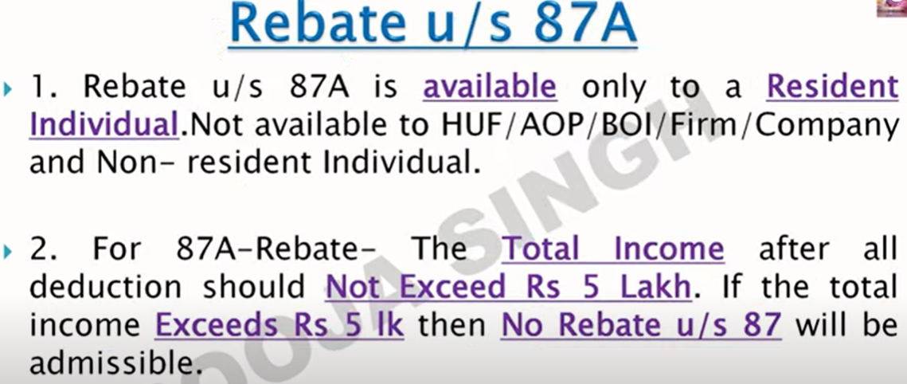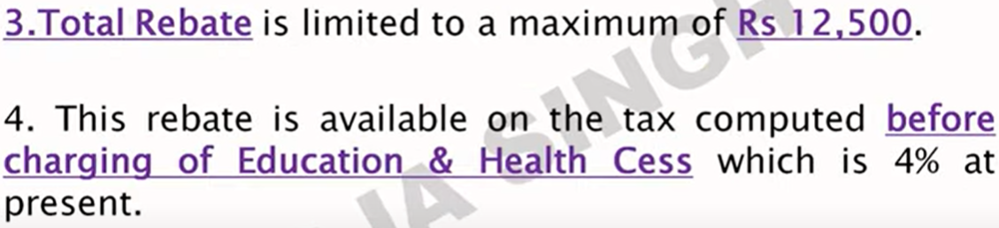

Decoding PAN

1. 5th letter in PAN Number is first letter of last name.
2. 4th letter can be P for individuals, C for Company, A for association, F for firms, H for HUF & T for trust.
3. First 3 letters are random alphabets from AAA to ZZZ.
4. Last digit is check digit.
5. 6-9th digits are random number from 0000 to 9999.

Income tax for reading it

<https://incometaxindia.gov.in/pages/acts/income-tax-act.aspx>

**5 Heads of Income**

1. Salary
2. House Property
3. Business or Professions.
4. Capital Gains(Short & Long)
5. Income from Other Sources

Combining the income from all 5 heads will give us **Aggregated Income** (**AI**).  
Subtracting Clubbing Provisions and Set Off/Carry forward of losses from Aggregated Income will give us **Gross Total Income** (**GTI**).  
Income tax offers certain deductions (below) on GTI, Subtracting these deductions will give us **Total Income** or **Taxable Income** (**TI**).   
Some of commonly used Deductions are deductions under Section 80C, Standard deductions of ₹50000 ,Professional Tax, 80CCD(1B) for NPS, 80D, 80TTA, LTA, HRA, etc  
Very important to note that is Tax is always calculated on Total Income only.

Losses of one head may be or may not be adjusted to income of other head.

1. Chapter 4 of IT Act deals with calculation of Head Wise Income.
2. Chapter 5 of IT Act deals with clubbing provisions
3. Chapter 6 of IT Act deals with adjustment of losses with different heads and carry forwarding of losses.
4. Chapter 6A deal with deductions such as 80C, 80 CCD(1B), 80G, etc.

Chapter 4 + Chapter 5 – Chapter 6 = GTI.

GTI – Chapter 6A = TI. Now tax will be applicable as per Slab rate.

**Residential Status of Tax Payer**

If an individual is in India for at least 182 days in one financial year then he/she will become resident of India in the eyes of tax payer.

For Residents, the Global Income will be taxable.

For Non Residents only Indian income will be taxable.

**Scope of Income**

* Income accrued in India: Means income earned in India. It will be taxable for both residents and non residents.
* Income accrued outside India: Means income earned outside India. It will be taxable for Residents and not taxable for non residents.
* Income received in India : Taxable for residents and non residents both.
* Income received outside India : Taxable for residents and not taxable for non residents.

**TDS (Tax Deducted At Source)**

TDS will be reflected in Form 26AS on income tax portal.

**TCS (Tax collected at Source)**

**Advance Tax**

If net tax liability in any year is more than 10,000 then we are liable to pay advance tax.  
*Net Tax Liability* = Total tax liability – TDS –TCS- Relief on Arrear of salary U/S 89.

Due dates of Advance Tax  
15 June of FY (Should pay upto15% of Net Tax)  
15 Sept of FY (Should pay upto 45% of Net Tax)  
15 Dec of FY (Should pay upto 75% of Net Tax)  
15 Mar of FY (Should pay upto 100% of net Tax)

A senior citizen is not liable to pay advance tax.

**Self Assessment Tax**: Tax paid on requisite income after deducting Advance Tax, TDS, TCS .

**Regular Assessment Tax**: When IT Department finds that there has been understatement of income and resultant tax due, it takes measures to compute the actual tax amount that ought to have been paid. This demand raised on the person is called as Tax on regular assessment.

**Benefits of filling ITR**

1. For taking Loan
2. For taking an insurance
3. For claiming incentives from Government of India.
4. For employment purposes.

**Penalty of late filing of income tax (Sec 234F)**

If annual income is ₹5 Lakhs, the late fee would be ₹5,000.  
|If annual income is less than (or equal to) ₹5 Lakhs, then late fee is calculated as ₹1000.  
If annual income does not cross ₹2.5 Lakhs, you are not required to pay any income tax or a late fee for that matter.

If someone does not pay income tax then he/she is liable for prosecution from 3 months to 7 years of imprisonment

**Income from House Property**

House property can be self occupied or can be rented.  
Note: Rent from Commercial Property will be taxed under house property head.  
Vacant Property will not be considered for taxation as no rent is earned from it.

Deduction on House

* U/S 24(a) An Assesse can claim standard deduction of 30% on rent from House Property.
* U/S 24(b) An Assesse can claim deduction of max ₹2,00,000 on interest paid in lieu of loan taken for purchase, construction, repair, renewal or reconstruction of the property.

**Income from Business & Profession**

Business Income can be Actual Business Income or Presumptive Business Income.  
Presumptive Business Income (mentioned U/S 44AD), is computed at min rate of 8% on turnover via non digital transactions and 6% on turnover via digital transactions. Tax will be calculated based on slab rate.

In Actual Business Income an individual must maintain a book of account where same is not applicable for presumptive income.

Like Business Income, Professional Income can be Actual Professional Income or Presumptive Professional Income.   
A professional having a gross revenue upto ₹ 50 lakhs can opt for the presumptive scheme of tax wherein he can straightaway offer 50% of the gross revenue as his taxable income and pay taxes as per his slab rates on such income.

Depreciation & Allowable expenses can be deducted to calculate Actual Business/Profession Income.

**Income from Capital Gain**

Capital Gains are levied on Capital Assets. Capital Assets include Securities (Equity, Mutual Funds, Debentures, and Bonds), Real Estate, Jewellery, etc.  
Capital Gains are decided on period of holding.

* Unlisted shares, land or building or both 🡪 Short term if held for less than or equal for 24 months, Long Term if held for more than 24 months.
* Securities listed in recognized stock exchange 🡪 Short term if held for less than or equal to 12 months, Long term if held for more than 12 months.
* Unit of debt oriented funds, Unlisted Securities other than shares, other capital assests 🡪 Short term if held for less than or equal to 36 months, Long term if held for more than 36 months.

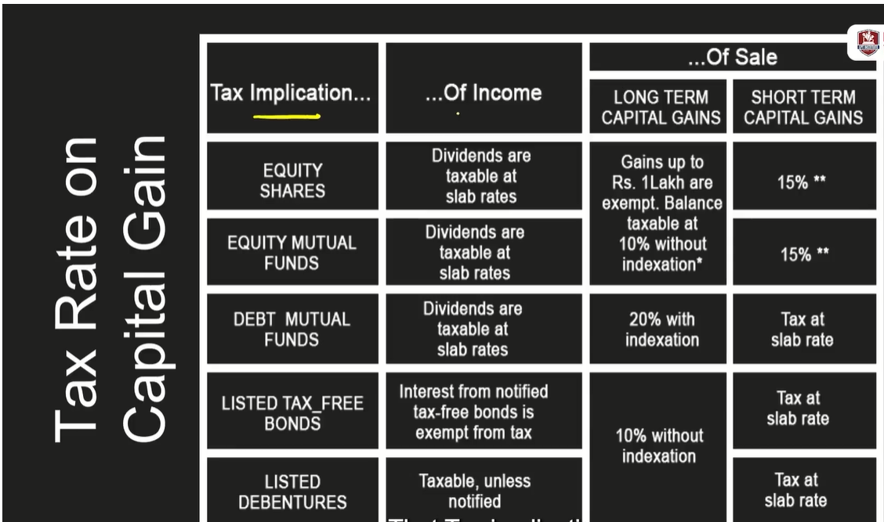

Intraday Stock Market income will be considered as Speculative income and will be treated under Business & Profession.

Delivery based Stock Market Income will be treated under Capital Gain or Capital Loss.

Futures and Options can be termed under Capital Gains or Business Income depending on circumstances.

Indexation is used to adjust the purchase price of an investment to reflect the effect of inflation on it. We can get Indexation benefits in LTCG but not in STCG.

**Other Source of Income**

* Interest income, Dividend Income
* Casual Income(Lotteries, Betting, Gambling, etc) 🡪 Straight away taxable at 30%
* Advanced Received

Other sources of income will be taxable at slab rate.

**Deductions against Salary**

For Salaried Person only 2 deductions can be claimed

Standard Deduction: ₹50,000 can be claimed for salaried employees.  
Deduction for Professional Tax

Reimbursements are not taxable.  
Bonuses are taxable.  
Advance Salary is taxable.  
Leave Encashments are taxable.  
ESOPs are taxable. They can be taxable under salary slab and further by LTCG as well.

Taxes are calculated on in-hand salary and not on CTC.

**Exemptions in Allowances and Retirement Benefits**

HRA can be claimed if the salary structure has HRA component.

Assessee should be staying in rented premises.

HRA deduction available is the least of the following amounts:

* Actual HRA received
* 50% of [basic salary + DA] for those living in metro cities (Delhi, Kolkata, Mumbai or Chennai) or 40% of [basic salary + DA] for those living in non-metros
* Actual rent paid (-) 10% of basic salary + DA

**LTA (Leave Travel Allowance)**

Conditions to be met for claiming Leave travel allowance as exemptions are as follows :

* Actual Journey is must for concession.
* Only domestic travel is considered no International travel is available for concession.
* Under Rule 2B, exemption will be available only in respect of two Journeys in block of four calendar years which start from the year 1986.
* Where such leave travel concession is not availed by employee in any block of four years, one such LTC will be carried forward immediately next block of four calendar year.

**Taxation on Provident Fund**:

* PPF comes under EEE model.
* In EPF, The Employer’s contribution is tax free and Employee’s contribution to deductible under 80C, but becomes taxable if withdrawn before the span of 5 Years.

**Taxation on Gratuity**

Least of the following is exempt from tax.

* Last salary (basic + DA)* number of years of employment* 15/26;
* Rs. 20 lakhs
* Gratuity Actually received

**Taxation on Leave Encashment**

Least of following is exempt from tax.

* Actual amount received
* 10 month’s average salary
* Cash equivalent of unavailed leave calculated on the basis of maximum 30 days leave for year of actual service rendered or
* 3 lakh

**Adjustment of House Property losses against Salary**

On taking a home loan, we are entitled to pay EMI. This EMI can be used in deductions in income tax law.

The EMI contains 2 components:

1. Interest payment (deduction can be claimed under U/S 24(B))
2. Principal payment (U/S 80C)

Interest payment deduction (U/S 24(B)) can be claimed under House Property Head.

In House Property an Assessee can have 2 types of house property

* Self Occupied
* Rented

Taxation of House property is based on Annual Value. Annual Value of Self Occupied property is nil, where as Annual value of Rented property is Rent earned from the property.

Note: Vacant Land is not house property.

Income Tax offers 2 types of deductions on both Rented and Self Occupied properties.

* 30% of Annual Value as Standard deduction (Just like Standard Deduction of 50K on salary).
* Interest on House Property or House property Interest (H.P.I).

1. On Self occupied property maximum of ₹2,00,000 of House property Interest can be claimed annually.

2. On Rented Property there is no limit for claiming of House property Interest.

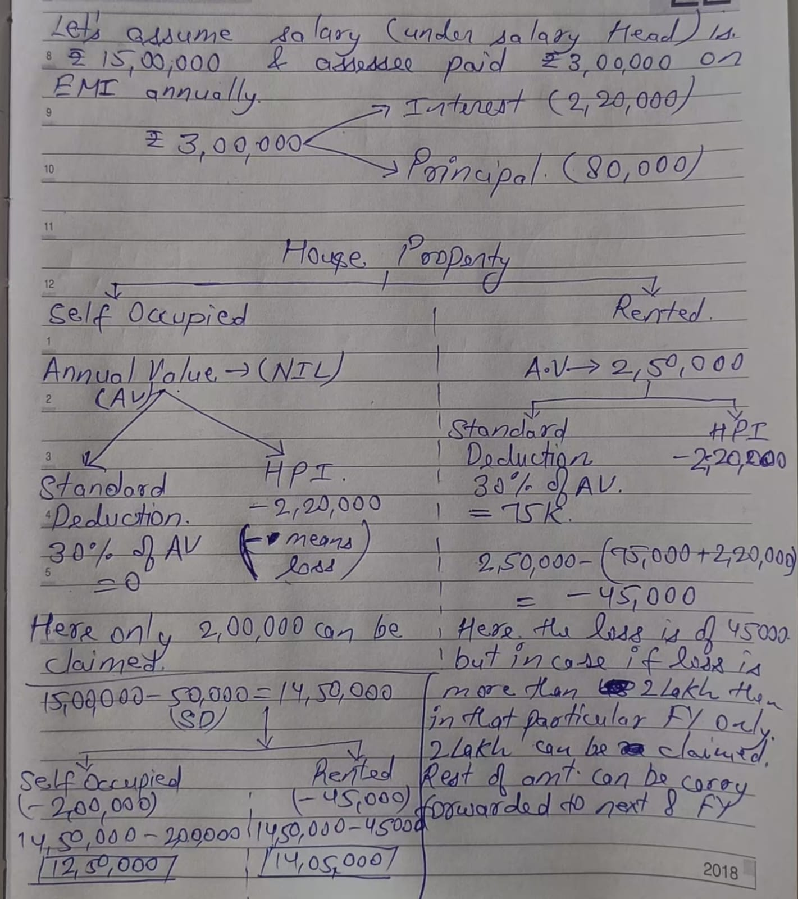

Note: If a person has self occupied property in Jaipur and is living in Pune on Rent, then in this case he can claim both HRA and Home loan interest.

**Deductions against Salary Income (80C)**

EEE Model : Exempt Exempt Exempt category is tax exemptions on investment, interest/return and maturity.

ETT Model : Exempt Taxable Taxable category is tax exemptions on investment, but taxable on interest/return and maturity.

**Deductions under 80CCD (NPS)**

Section 80CCD has been further divided into two subsections.

1. **80CCD(1) :**

* Defines the rules related to income tax deduction available to individuals (Employees or Self Employed) for contributions made to the NPS.
* The maximum deduction permissible for employees is 10% of their salary (basic + DA) in the previous year.

1. **80CCD(2) :**

* Is available when an employer is contributing to the NPS of an employee. An employer can make contributions towards NPS in addition to those made towards PPF and EPF. The contribution made by the employer can be equal to or higher than the employee's contribution.
* Section 80CCD (2) applies to only salaried individuals and not to self-employed individuals.
* Allows a salaried individual to claim a maximum deduction of 10% of their salary (basic + DA) contributed by any other employer towards NPS.

Note:

* A new amendment to Section 80CCD has been introduced as sub-section (1B). Under these new provisions, individuals can claim an additional deduction of Rs. 50,000/-. This is available to both salaried as well as self-employed individuals. Thus, the maximum deduction available under Section 80CCD is Rs. 2 lakhs. Tax benefits under Section 80CCD (1B) can be claimed over and above the deductions available under Section 80CCD (1).
* To be eligible for Income Tax deduction under the NPS Tier 1 Account, one must contribute a minimum of Rs 6,000 per annum or Rs 500 per month. To be eligible for Income Tax deduction under the NPS Tier 2 Account, one must contribute a minimum of Rs 2,000 per annum or Rs 250 per month.
* The combined deduction under Section 80C and 80CCD cannot exceed Rs 2 lakhs.

**Health Insurance Premium**

Section 80D of the Income-tax Act, 1961 allows an individual to claim deduction from gross taxable income. The deduction can be claimed if an individual has paid medical insurance premium during the year for self, spouse and dependent children.

|  |  |  |  |
| --- | --- | --- | --- |
| Scenario | Premium Paid | | Deduction Under 80D |
|  | Self, Spouse, Children | Parents |  |
| Individual and parent below 60 years | 25,000 | 25000 | 50,000 |
| Individual below 60 years but parents above 60 years | 25,000 | 50,000 | 75,000 |
| Both individual and Parents above 60 years | 50,000 | 50,000 | 1,00,000 |

Insurance Premium should be paid only via electronic means/cheque

Note: Health Check Expenses (upto Rs 5,000) are also covered under 80D alongside premium. Also health check expenses can be paid in cash.

**Education Loan Repayment**

Only the interest part of Education Loan can be claimed U/S 80E.  
To take deduction of Education loan repayment, loan must be taken for only for higher studies of self, spouse or children.

**Saving Account & FD Interest**

U/S 80TTA an assessee who is not senior citizen can claim upto Rs 10,000 for saving account interest.

Saving account must be with either from Scheduled bank or Cooperative bank or Post office saving Account

FD interest are not covered under 80TTA and will be taxable as per slab rate.

U/S 80TTB an assessee can claim upto Rs 50,000 deduction on Interest of Saving Account & FD provided assessee is a Senior Citizen and resident of India.

**Donations**

U/S 80G an assessee can claim deduction for the donations made.

Individuals, Companies, Firms, Hindu Undivided Firm (HUF),Non-Resident Indian (NRI) can claim a deduction U/S 80G.

Donations have to made via electronic means or via cash (not more than Rs 2,000) and with a valid receipt.

Various donations specified in Section 80G are eligible for a deduction of up to 100% or 50% with or without restriction (which in specific cases are subjected to 10% of adjusted gross income).

The deduction is not available if you are opt for the new tax regime.

**Taxation of Gift**

What is a Taxable Gift from according to IT Act?

1. Money (Can be via electronic means or cash)
2. Real Estate
3. Other Assets(Share & Securities, Jewellery, Artwork, Sculptures, Drawing & Painting)

All the above 3 are collectively called Specified Asset as per U/S 56(2)(x).

Whether Gifts are taxable or exempt?

* Gifts which are covered under the umbrella of U/S 56(2)(x) are taxable.  
  If the gift received is not covered under this umbrella then such gifts are exempt from income tax.

List of relatives from whom gift may be received.

* Taxable Gifts received from specified person (relatives) are exempt, otherwise taxable.
* List of relatives are as follows:
* Spouse of individual.
* Brothers or Sisters of individual
* Brothers or Sisters of Spouse of individual
* Brothers or Sisters of Parents of individual
* Linear ascendant or descendant of individual.
* Linear ascendant or descendant of Spouse of individual.
* Spouse of any person referred above.

Events or Circumstances under which Taxable gifts received are not taxable.

* Marriage of individual.
* Under a will or way of inheritance.

Exemptions for gifts received from Non Relatives or on Non Specified Events.

If the aggregated value of gifts (Money + Real Estate + Other Assets) received is less than 50,000 then they are not taxable, otherwise the whole amount will be taxable.

**Note :**U/S 269ST Under no circumstances cash received should not exceed more than 2Lakhs from one person in single day, otherwise penalty will be attracted equivalent to cash received.

**Clubbing Of Income**

Clubbing of income is specified U/S 64 of IT Act.  
Clubbing of income means adding or including the income of another person (mostly family members) to one’s own income.

Acceptance and repayment of Unsecured loan.

Any deposit or loan of more than Rs 20,000 in cash is not allowed. Violation can invite a penalty under Section 271D, which can be equal to the loan or deposit amount.

**Tax Slabs**

What are different types of tax rates?

* Normal Tax Rate (Slab Rate)
* Special Tax Rate (Mention U/S 111A, 112, 112A, 115BB of IT Act)

What is Surcharge & Cess?

* 0-50 Lakhs : Surcharge is nil
* 50 Lakhs – 1 Crore : Surcharge is 10%.
* 1 Crore – 2 Crore : Surcharge is 15%.
* 2Crore – 5 Crore : 25%.
* 5 Crore and above : 37%.

Cess is applied on (Surcharge and Tax) Calculated combined.

**Difference between old & new slab rate**

Limitations of new Slab rate:

1. No HRA exemption can be claimed
2. No Exemptions on LTA or any type of allowances.
3. No Standard deduction, deduction on professional tax.
4. No deductions of 80C, and 80D (Insurance Premium).
5. No deduction for 80CCD(1B)
6. No deduction U/S 80TTA (saving bank interest)
7. No Adjustment of loss from house property against salary income for self occupied house property.

**How rebate under 87A is computed?**

If total income is less than 5,00,000 then we are entitled to get a rebate of 12,500 or payable tax whichever is less.

**How to compute final tax liability?**

1. Chapter 4 of IT Act deals with calculation of Head Wise Income.
2. Chapter 5 of IT Act deals with clubbing provisions
3. Chapter 6 of IT Act deals with adjustment of losses with different heads and carry forwarding of losses.
4. Chapter 6A deal with deductions such as 80C, 80 CCD(1B), 80G, etc.
5. Distinguish the taxable income as per normal rate & special rate.
6. Determine Total tax liability (subject to 87A relief)
7. Enhance Total tax liability with Surcharge & Cess
8. Reduce TDS/TCS/Advance Tax, Relief U/S 89, 90, 90A, 91.
9. Add interest U/S 234A, 234B, 234C.
10. Add fees for delayed filing of ITR U/S 234F

If taxable payable is less than tax actually paid then we can claim refund as well.

Chapter 4+ Chapter 5 – Chapter 6 = GTI.

GTI – Chapter 6A = TI. Now tax will be applicable as per Slab rate.

**Computation of Interest**

Interest is computated U/S:

* Sec 220 : 1% Interest for not fulfilling the demands of extra tax as per assessment order (U/S 143(3)) or intimation order (U/S U/S 143(1)) with in 30 days .
* Sec 234A : Interest in delayed filing of ITR.
* Sec234B : Interest on short payment of Advance Tax. It is applied after FY
* Sec 234C : Interest on Deferment of tax payment. Interest of 1% is levied. It is applied during FY.
* Sec 234D : Interest for claiming excess refund.

Good examples for Computations of interest and fees for delayed filing if ITR.

**Tax Planning**

1. PPF – It comes under EEE Model. It is safeest
2. NSC – It comes under EET. It is safest
3. Sukanya Samridhi Yojna – EEE. It is safest return.
4. Example on LIC.
5. ELSS – lock in period of 3 years. LTCG may be taxable.
6. Provident Fund – Find the taxability of this under certain circumstances.
7. 5 Year Tax saver FD : comes under ETE model.
8. NPS is taxable partly

Some important forms

1. Form26AS
2. Annual Information Summary
3. Taxpayer Information Summary
4. Intimation Order

Password for intimation order = pancard in lower case + DOB in DDMMYYYY format

For Salaried income usually ITR-1 is applicable

For individual dealing with share market and have incurred Capital Gain Income, ITR-2 is applicable.

If salaried individual is doing freelancing, then ITR-4 is applicable.

**Assessment Procedure**

Assessment is for validating legitimate claims and other proofs. CPC will mail assessee for letting them know that an assessment has been opened for them.

Assessments are done under

* Scrutiny Assessments (U/S 143(3)) for limited time period
* U/S 147 for period upto 10 years.

**Claim U/S 89**

You do not pay more taxes if there was a delay in payment to you and you were in a lower tax bracket for the year you received the money.

Form 10E should be filled for this claim.

And this form should be filled before filling the ITR.

What all are covered under 80C (Deductions on investment)

1. **Life Insurance Premiums** either for yourself or family members.  
   Tax on Returns: The returns on life insurance policies, where the insurance cover is at least 10 times the annual premium, are exempt from tax under Section 10(10)(D) of IT Act.
2. **Investment in ELSS mutual funds**: ELSS mutual funds have a lock-in of 3 years and invest 80% of their corpus in equities (stocks). Falls under ETT Model

Tax on Returns: ELSS returns above Rs 1 lakh are subject to long term capital gains tax at a rate of 10%.

1. **Public Provident Fund:** It has a tenure of 15 years.  
   Tax on Returns: PPF returns are exempt from tax. However you have to declare PPF returns in your income tax return each year. It falls under EEE Model.
2. **Employees’ Provident Fund (EPF)**: Employees’ contribution to the EPF account is eligible for deduction under Section 80C.  
   Tax on Returns: EPF interest rate is tax free. However it becomes taxable when you leave service at an EPF registered company. The interest also becomes taxable if EPF is withdrawn before completion of 5 years of service with an EPF registered company.
3. **Tax Saving Fixed Deposit**: The 5 year tax-saver fixed deposits at banks and post offices are eligible for tax deduction.

Tax on Returns: The interest on such fixed deposits is fully taxable.

1. **National Pension System (NPS)**: The NPS deduction is granted by Section 80CCD (1) and (2).Employer’s and employees’ contributions to the NPS are both tax deductible under Section 80C. However employer’s contributions cannot be more than 10% of your basic salary + dearness allowance, in order to get the benefit of this section. Self-employed person can also claim this benefit for contributions up to 20% of gross income. In addition, voluntary contributions to the NPS up to Rs 50,000 are exempted over and above the Rs 1.5 lakh under Section 80 C. These voluntary contributions are covered under Section 80CCD (1B).

Tax on Returns: NPS returns are tax exempt until maturity. At maturity, 40% of the accumulated corpus is tax free.

1. **National Savings Certificate**: National Savings Certificates are a government backed savings instrument with a 5 year tenure. The interest on these certificates is also eligible for tax deduction under Section 80C.

Tax on Returns: Returns on NSCs are also eligible for tax deduction under Section 80C.

1. **Senior Citizens’ Savings Scheme (SCSS):** This is a government-guaranteed savings instrument with a tenure of 5 years which can be extended for an additional 3 years.

Tax on Returns: SCSS returns are fully taxable at your slab rate.

1. **Sukanya Samriddhi Yojana**: This is a government supported savings scheme for the girl child. It can be opened by parents of a girl child who is below the age of 10. The scheme has a tenure of 21 years or until the girl child gets married after the age of 18.Tax on Returns: Returns on the Sukanya Samriddhi Scheme are tax free.
2. **Tuition fees** for any school, college or university for up to two children.
3. **Home loan** principal repayment.

Important Sections in IT ACT

* Sec 10(5) : allows salaried individuals to claim exemptions for LTA
* Sec 10(10) : Gratuity
* Sec 10(13A) : allows salaried individuals to claim exemptions for HRA.
* Sec 16 : For standard deduction, entertainment allowance and professional tax.
* Sec 24(B) : Allows a taxpayer to claim a deduction on the interest of a loan
* Sec 44AD : Tax on Presumptive income
* Sec 56(2)(x) : Gifts and it’s taxability.
* Sec 80C : 1.5 lakhs income
* Sec 80CCD(1) : Employees Contribution to NPS
* Sec 80CCD(1B) : Additional deduction of 50,000 under NPS.
* Sec 80CCD(2) : Employer’s contribution to NPS.
* Sec 80D : Deduction for Medical insurance
* Sec 80E : claim a deduction of Interest paid on a loan taken for pursuing higher education
* Sec 80TTA : Deduction on saving bank interest for non senior citizen
* Sec 80TTB : deduction on saving bank & FD interest for senior citizen.
* Sec 80DD, 80DDB, 80U : Deduction for disability
* Sec 87A: Rebate if salary is less than 5 Lakhs.
* Sec 89 : you do not pay more taxes if there was a delay in payment to you and you were in a lower tax bracket for the year you received the money
* Sec 111A : Short term Capital Gain of Listed Securities
* Sec112 : Long Term Capital Gain
* Sec 112A : Long term Capital Gain from sale of listed securities, Shares or Mutual Fund unit, if Capital gain is more than Rs 1,00,000.
* Sec 115BB : Casual Income.
* Sec 139(1) : Mandatory filing of Income Tax Return if GTI is greater than 2.5Lakhs.
* Sec 143(2) : Gives second chance to the assessee after Income Tax Department finds major or minor discrepancies in the tax return.
* Sec 192 : Deduction of TDS at time of payment.
* Sec 220 : Interest for being an assessee in default.
* Sec 234A : Interest in delayed filing of ITR.
* Sec234B : Interest on short payment of Advance Tax
* Sec 234C : Interest on Deferment of tax payment. Interest of 1% is levied.
* Sec 234D : Interest for claiming excess refund.
* Sec 234F : Penalty of late filing of Income tax
* Sec 269SS : any deposit or loan of more than Rs 20,000 in cash is not allowed. Violation can invite a penalty under Section 271D, which can be equal to the loan or deposit amount.
* Sec 269ST: Penalty for Cash payment of 2 Lakhs from one person in single day.
* Sec 276CC : Prosecution for not paying Income Tax.